DIGITAL HEALTH RECORDS MANAGEMENT
SYSTEM FOR FILAMER CHRISTIAN UNIVERSITY CLINIC

A CAPSTONE PROJECT PROPOSAL
Presented to the Faculty
The College of Computer Studies
Filamer Christian University
Roxas, City, Capiz, Philippines

In Partial Fulfillment
of the Requirements for
CS 8 – QUANTITATIVE METHODS

By
DOLFO, REI ASHLEY
EBACUADO, STEFAN JOHN M.
BANAY, JOSEPH MARIE D.
AQUINO, LOR FREDERICK JAMES R.

February 2025

TABLE OF CONTENTS

TITLE PAGE……………………………………………………………………………… i
TABLE OF CONTENTS………………………………………………………………… ii
LIST OF FIGURES……………………………………………………………………… iii
LIST OF APPENDICES………………………………………………………………… iv
CHAPTER
I INTRODUCTION
Overview of the current state of technology 1
Desired State of the Technology 2
Statement of the Problem 2
Objectives of the Study
General Objective 3
Specific Objectives 3
Theoretical and Conceptual Frameworks
Theoretical Framework 3
Conceptual Framework 5
Operation Definition of Terms 8
Scope and Limitations of the Study 9
Significance of the Study 9
II REVIEW OF LITERATURE AND STUDIES 11
III METHODOLOGY 23
BIBLIOGRAPHY 31
CHAPTER I
INTRODUCTION

Overview of the Current State of Technology
School clinics play a crucial role in ensuring the health and well-being of students by maintaining medical and dental records. At present, the medical and dental clinic of Filamer Christian University (FCU) relies on a manual record-keeping system. The current workflow involves retrieving past records from metal locker drawers or requiring students to fill out a new form if no prior record is found. Medical personnel interview patients and document findings manually, which can lead to inefficiencies in record retrieval and management.
The existing system poses several challenges. Students sometimes forget they have past medical records, leading to the creation of duplicate records. Additionally, charts are often not returned in an organized manner, making retrieval difficult. While records are updated regularly when a patient returns, the manual process is time-consuming. The clinic also requests masterlists from each department to update records and decongest files by removing records of graduates and dropouts. However, this process remains labor-intensive and prone to errors.

Desired State of Technology
To address these concerns, a Digital Health Records Management System is proposed. This system aims to streamline the documentation process, improve record retrieval, and reduce duplicate records by automating medical history tracking. By transitioning from a manual to a digital system, the clinic can enhance efficiency, reduce administrative workload, and ensure better healthcare services for students.
Statement of the Problem
The current manual system for managing medical and dental records at the FCU clinic presents several issues:
- Duplicate Records: Students who forget about their previous medical records end up filling out new forms, leading to redundant records and inefficiencies.
- Disorganized Charts: Physical medical records are often returned in a disorderly manner, making retrieval time-consuming.
- Slow Record Retrieval: Since records are stored in metal locker drawers, staff members must manually search for a student’s history, delaying patient service.
- Labor-Intensive Updates: Updating medical records requires clinic staff to request masterlists from departments and manually pull out records of graduates or dropouts.
These challenges highlight the need for a Digital Health Records Management System that will improve accessibility, efficiency, and accuracy in medical record-keeping.

Objectives of the Study
General Objectives
To develop a Digital Health Records Management System that will digitize and improve the documentation and retrieval of medical and dental records at the FCU clinic.
Specific Objectives
- Automate Patient Record Retrieval: Prevent duplicate records by implementing a system that checks existing medical history before creating a new entry.
- Digitally Organize Medical History: Store patient records in a centralized database for easier retrieval and updating.
- Implement User Roles for Secure Data Handling: Assign access levels to different staff members (e.g., working students, nurses, and doctors) to ensure privacy and data security.
- Updating and Record Maintenance: Provide a feature that allows clinic staff to update student records efficiently and remove inactive files when necessary.

Theoretical and Conceptual Frameworks

Conceptual Framework
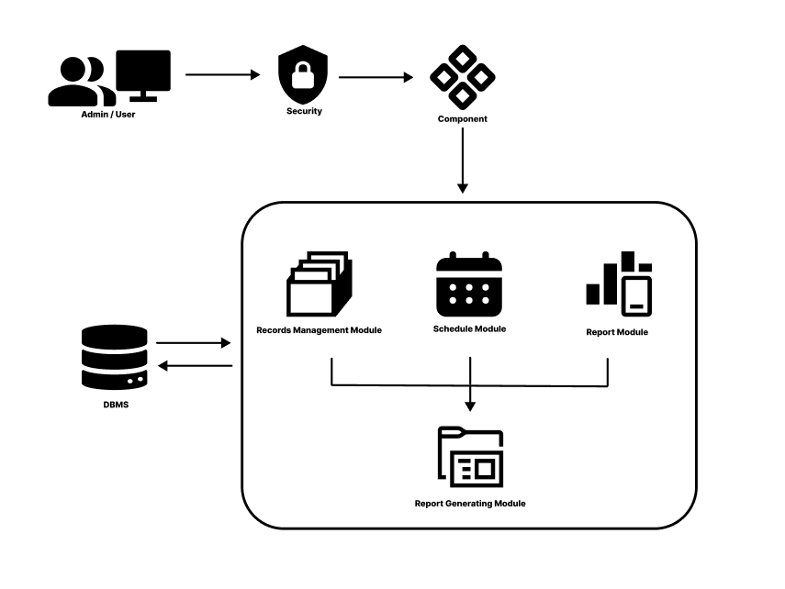
Figure 1 Conceptual Framework of Digital Health Records Management System

The conceptual framework for the Digital Health Records Management System for FCU is structured to integrate multiple components that ensure secure, efficient, and comprehensive management of health records.

Administrators
These admins interact with the system through a dedicated interface that emphasizes ease of use and accessibility, ensuring that they can quickly and reliably access patient information and other critical functionalities.
Security/Auth/Login
A critical element of the framework. This layer is designed to enforce robust authentication measures to ensure that only authorized personnel can access the system. By incorporating multi-factor authentication and role-based access control, the security module not only protects sensitive patient data from unauthorized access but also tracks user activities for audit and compliance purposes. This security infrastructure is vital for maintaining data integrity and ensuring that the system adheres to relevant data protection regulations.
Home
Once authenticated, users gain access to the modules of the system.
Records Management Module
It is central to the framework, as it handles all operations related to the creation, updating, storage, and retrieval of patient health records. This module is designed with flexibility and scalability in mind, enabling healthcare professionals to manage diverse types of data from medical histories and lab results to treatment plans and diagnostic images while ensuring that data is structured in a standardized format for easy retrieval and interoperability.
Schedule Module
This module organizes appointments, consultations, and other time-sensitive activities. This module allows users to manage schedules efficiently by providing features such as calendar integration, appointment reminders, and conflict resolution mechanisms. The scheduling function is crucial for streamlining the workflow of healthcare providers, ensuring that patient consultations and follow-ups are conducted in an organized and timely manner.
Report Module
The report module which is linked to the Report Generating Module, work together to compile, analyze, and generate reports based on the data stored within the system. The reporting functions are designed to support decision-making by providing insights into patient outcomes, system performance, and operational efficiency. Reports can be customized to focus on specific parameters such as patient demographics, treatment effectiveness, or resource utilization, thereby aiding healthcare administrators in monitoring performance and identifying areas for improvement.
Database Management System (DBMS)
Underlying the entire framework is the which serves as the centralized repository for all health records and system data. The DBMS is engineered to ensure high performance, data consistency, and robust backup and recovery capabilities. It supports complex queries and data indexing, which are essential for quick data retrieval and efficient system operation. The integration of a powerful DBMS ensures that the vast amounts of data generated by the system are stored securely and can be accessed reliably by authorized users.

Operational Definition of Terms
- Digital Health Records Management System (DHRMS) – A computerized system designed to store, manage, and retrieve patient health records digitally for FCU.
- Electronic Health Records (EHR) – A digital version of a patient’s paper chart that contains medical history, treatments, and test results.
- Data Security – Measures taken to protect digital health records from unauthorized access, corruption, or loss.
- Usability – The ease of use and efficiency of the system for healthcare professionals and administrators.
- System Reliability – The ability of the system to function correctly and consistently over time without failures.
- Data Redundancy – The unnecessary duplication of patient information, which the system aims to eliminate.
Scope and Limitations of the Study
This study focuses on the development and implementation of a Digital Health Records Management System (DHRMS) for Filamer Christian University (FCU). The system is designed to store, manage, and retrieve patient health records digitally, improving efficiency, security, and accessibility of medical data. It will be used by healthcare personnel and administrators within FCU’s health facility to track, update, and manage patient information. The study covers the design, development, and evaluation of the system, assessing its functionality, usability, security, and performance. It will follow software development methodologies and include consultations with IT and healthcare professionals for validation.
However, the system has certain limitations. It is limited to FCU’s healthcare facility and does not extend to external hospitals or clinics. The system focuses only on record management and does not include advanced AI-based diagnostics or automated medical decision-making. The study is constrained by available resources, time limitations, and institutional policies regarding health data privacy. Since the system requires internet connectivity for real-time updates, offline functionality will be limited or unavailable.
Despite these limitations, the study aims to provide a reliable, secure, and user-friendly digital health records system that enhances patient data management and supports the transition toward modernized healthcare operations at FCU.

Significance of the Study
The Digital Health Records Management System (DHRMS) for Filamer Christian University (FCU) is significant in enhancing healthcare services within the institution. By transitioning from traditional paper-based records to a digital system, it ensures a more efficient, secure, and accessible way of managing patient health information. This digital approach minimizes errors, reduces paperwork, and streamlines the record-keeping process.
For healthcare personnel, the system provides a more organized and systematic method of storing and retrieving medical records. It improves efficiency in accessing patient information, leading to better decision-making and faster medical interventions. By reducing manual documentation, healthcare providers can focus more on patient care rather than administrative tasks.
For FCU as an institution, implementing a digital health records management system modernizes its healthcare services. The system ensures compliance with data security and confidentiality standards, aligning with best practices in medical record management. It also improves administrative operations by reducing redundant processes and enhancing the overall workflow.
For students and employees, the system offers a more convenient and efficient way to manage health records. By having easy access to their medical history within the institution, they can receive timely and accurate medical assistance. The digital system ensures that their health data is securely stored and readily available when needed.
For future researchers, this study serves as a valuable reference for the development of health information systems. It provides insights into the challenges and benefits of implementing digital record management in an educational institution’s healthcare setting. The findings of this study may help guide further improvements and innovations in digital health solutions.

CHAPTER II
REVIEW OF RELATED LITERATURE

Overview
This study provides some references to back up information that is connected and related to the development of a Digital Health Records Management System for FCU. The review of related literature includes studies and research papers that discuss health information systems, electronic medical records, data security, and system usability. These references serve as the foundation for understanding the significance of digital record-keeping in healthcare, the challenges faced by traditional paper-based systems, and the benefits of transitioning to a secure and efficient digital platform.
Furthermore, this chapter presents various local and international studies that highlight the importance of information accessibility, patient data security, and system effectiveness in healthcare institutions. By analyzing existing research, this review aims to identify gaps that the proposed system seeks to address and demonstrate how the implementation of a digital health records management system can enhance data organization, retrieval efficiency, and patient care services at FCU.

Assessment of Electronic Health Record Use Between US and Non-US Health Systems
A study comparing EHR usage between US and non-US health systems found that US clinicians spend significantly more time on documentation, system-generated messages, and after-hours EHR use than their international counterparts. This highlights the challenges of EHR burden and inefficiencies in digital health systems.
The study emphasizes the need for streamlined digital health records to reduce administrative workload and improve efficiency. Applying these insights, the proposed Digital Health Records Management System for the FCU clinic aims to automate documentation, enhance record retrieval, and minimize redundant tasks to improve overall clinic operations. (Jay Holmgren et al, 2021)

Measurement of clinical documentation burden among physicians and nurses using electronic health records: a scoping review
Another study focused on the documentation burden among physicians and nurses using EHRs, identifying that excessive documentation workload contributes to clinician burnout. The study found that documentation burden is difficult to measure due to a lack of standardized methods but identified key factors affecting it, including EHR workload, administrative tasks, after-hours work, workflow fragmentation, and cognitive effort. The research concluded that further studies are needed to operationalize and standardize documentation burden measurement to enhance clinician productivity and well-being. (Amanda J Moy et al, 2021)

Analysis of Digital Information Management Strategies by the Faculties of Higher Education Institutions
This study investigates the Digital Information Management (DIM) practices of faculty members in higher education institutions, focusing on the storage, preservation, and access of personal and professional digital information. The findings indicate that nearly 50% of faculty members regularly manage their digital content, with the majority using formats like PDFs and image files for storage. Popular tools for digital preservation include Google Drive, pen drives, and Gmail, which faculty consider secure for long-term storage. Key advantages of DIM include time-saving, easy access, and efficient storage, although challenges like technical issues and the cost of digital devices persist. Faculty members often acquire their ICT skills through self-learning and guidance from colleagues. The study concludes that DIM plays a vital role in the academic community, supporting the transition from print to digital formats, while emphasizing the knowledge-intensive processes involved in acquiring, storing, and accessing digital content. (Ashoka R et al, 2023)

A Smart And User-Friendly Interface For Storing And Retrieving Personal Medical Records
This study presents a web application designed to manage electronic health records (EHR) for both hospitals and patients. It highlights the need for secure, digital storage systems to prevent the loss of medical data, facilitate quick access to patient records, and ensure proper documentation for medical treatment and legal purposes. The system provides an interface for hospital officials to record patient treatments and medications, while allowing patients to access their own medical transactions, which are automatically updated. This approach is essential for accurate medical history analysis, proper medication prescriptions, and supporting legal processes such as insurance claims or malpractice cases.
The study emphasizes the importance of maintaining secure and accessible medical records, which can serve as proof in medical negligence claims. The proposed system aims to enhance efficiency and security in medical record management, benefiting both healthcare providers and patients. While focusing on user interface design, the system also addresses issues related to medical auditing and statistical analysis. (G. Swathi et al, 2022)
Document Management System – A Way To Digital Transformation
In the context of Digital Health Records Management Systems, a study by Jordan et al. (2022) explores the broader concept of Document Management Systems (DMS) as part of digital transformation in businesses. The paper discusses how DMS helps businesses digitize their workflows, increase efficiency, reduce operational costs, and contribute to a paperless environment. While this article mainly focuses on general office documentation, it emphasizes the importance of digital solutions in business processes, which can be applicable to health records management by ensuring better data management, cost savings, and efficiency. It also highlights key advantages such as time savings, compliance with regulations, and environmental benefits, all of which are important considerations for the digitalization of healthcare systems. (Sandra Jordan et al, 2022)

Audit Of A Web-Based Electronic Documents And Record Management System (Wedrms): Oversight Efforts To Improve Administration In Higher Educational Institutions
The study by Richatul Jannah et al, 2022, discusses the audit of a Web-Based Electronic Documents and Records Management System (WEDRMS) for higher educational institutions. It highlights the importance of effective electronic records management for ensuring security, compliance, and efficiency. The research presents the significance of implementing an electronic records management system, conducting regular audits, and providing staff training to ensure system effectiveness. The findings suggest that proper management of electronic records can enhance productivity, collaboration, and decision-making. While the study is focused on educational institutions, the principles of auditing, compliance, and system security are relevant for Digital Health Records Management Systems, particularly for ensuring the confidentiality and security of sensitive health records in healthcare settings.

Electronic document management system for local area network-based organizations
This study highlights the development of an Electronic Document Management System (EDMS) tailored for local area network-based organizations. The system was designed to streamline document handling by digitizing records, improving document retrieval, and promoting real-time information sharing. The system’s emphasis on paper reduction, workflow efficiency, security, and compliance offers a valuable reference for the development of your Digital Health Records Management System, particularly regarding how electronic management systems can enhance access to and sharing of health records while maintaining strict adherence to privacy and security standards. This research provides practical insights on the benefits of document digitization and real-time data sharing, which can be directly applied to improve healthcare management processes within FCU's health records system. (Marlon V. Gamido et al, 2022)

Development of Document Management System (DMSys): A Step Forward to a Paperless Office
This study explores the development of a Document Management System (DMSys) that promotes a transition to a paperless office, enhancing organizational efficiency by digitizing document handling processes. The system enables the creation, updating, deletion, and retrieval of documents, significantly reducing the time and costs associated with paper use. It also highlights the environmental sustainability benefits of paper reduction, contributing to a greener workplace. This research is relevant to the Digital Health Records Management System at FCU, as it underscores the advantages of digitizing documents, improving workflow efficiency, reducing paper usage, and ensuring quick and secure access to important information. The implementation of DMSys also provides a model for transitioning to digital record-keeping and highlights the need for ongoing system maintenance and continuous improvements—key factors that should also be considered in the development of FCU's health records management system. (Rafizah Mohd Hanifa et al, 2023)

Health Record Management System – A Web-based Application
This study discusses the development of a web-based Health Record Management System designed to manage and store patient data in hospitals. The system allows doctors to upload and retrieve patient information, providing patients access to their records and enabling appointment bookings. It emphasizes the importance of data security and easy access for healthcare professionals and patients, key considerations for the Digital Health Records Management System at FCU. The study also highlights the user-friendly UI/UX design, which is essential for making the system accessible to users with varying levels of technological proficiency. The data storage and retrieval process and the security features discussed in this study are directly applicable to the development of an efficient, secure, and easy-to-use health records management system for FCU. (2022)

MediCord: A Web-Based Health Record Management System
The study on MediCord: A Web-Based Health Record Management System focuses on the design and development of a health record system for a health center, leveraging information technology to improve the efficiency and security of managing health data. The study follows the software development life cycle (SDLC), ensuring that the system is developed in structured stages and complies with best practices in software development. MediCord emphasizes the importance of data security, efficient information sharing, and the user-friendliness of the system, which are all essential components for developing a similar system at FCU. This study provides a useful reference for understanding the design, development, and implementation of a web-based health record management system that could be adapted for university use. (Cris Norman Olipas, 2022)

Public Health Record Management System: An Up-Close Monitoring System
The study on the Public Health Record Management System (PHRMS) focuses on improving the efficiency, security, and reliability of electronic health records in a barangay health center. The system was developed to prevent data loss, reduce redundancy, and enhance data processing speed, ensuring a more effective patient record management process. The study followed a structured evaluation, consulting IT professionals, instructors, and healthcare workers, and assessed the system using software quality criteria such as functional suitability, usability, security, and reliability. The findings suggest that a secure, efficient, and user-friendly health records system can greatly enhance healthcare services—making this study a relevant reference for the development of FCU’s Digital Health Records Management System. (Jayson A. Batoon et al, 2022)

PARAMCS Document Management Software
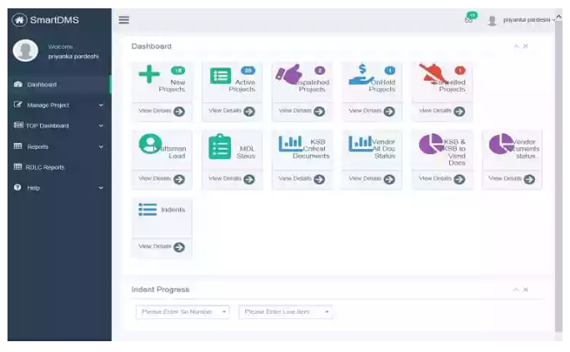
Figure 2 PARAMCS UI

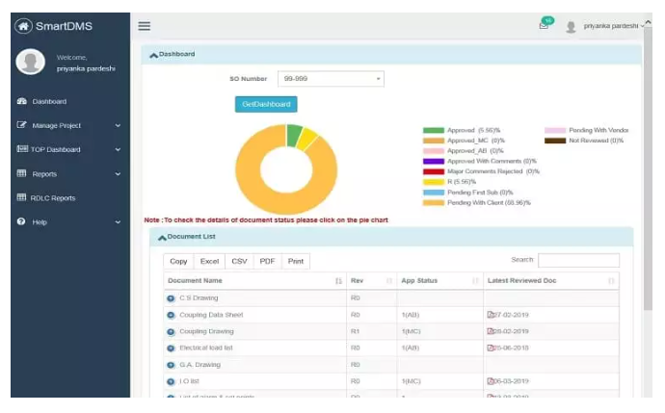
Figure 3 PARAMCS UI

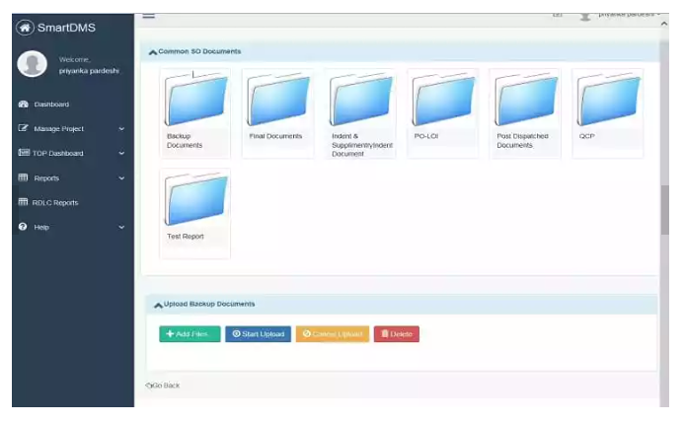
Figure 4 PARAMCS UI

Synthesis
Feature of the system | A | B | C | D | E | F | G | H | I | J | K
Electronic Health Record Management | ✔ | ✔ | ✔ | ✔ | ✔ | ✔ | ✔ | ✔ | ✔ | ✔ | ✔
User-Friendly Interface |  |  |  |  |  |  |  | ✔
Web-Based Accessibility | ✔ | ✔ | ✔ |  |  | ✔
Real-Time Data Update |  |  |  |  |  |  |  | ✔
Document Retrieval |  |  |  |  | ✔ | ✔
Document Storage and Archiving |  |  |  |  |  | ✔ | ✔
Graphical User Interface (GUI) |  |  |  |  |  |  |  |  |  |  | ✔
Table 1. List of Related Studies and Features

A - Public Health Record Management System: An Up-Close Monitoring System
B - Medicord: A Web-Based Health Record Management System
C - Health Record Management System – A Web-Based Application
D - Development Of Document Management System (Dmsys): A Step Forward To A Paperless Office
E- Electronic Document Management System For Local Area Network-Based Organizations
F - Audit Of A Web-Based Electronic Documents And Record Management System (Wedrms): Oversight Efforts To Improve Administration In Higher Educational Institutions
G - Document Management System – A Way To Digital Transformation
H - A Smart And User-Friendly Interface For Storing And Retrieving Personal Medical Records
J - Analysis Of Digital Information Management Strategies By The Faculties Of Higher Education Institutions
I - Measurement Of Clinical Documentation Burden Among Physicians And Nurses Using Electronic Health Records: A Scoping Review
K - Assessment Of Electronic Health Record Use Between Us And Non-Us Health Systems

The reviewed literature emphasizes the growing importance of transitioning from traditional paper-based systems to digital platforms in healthcare and related fields. Numerous studies highlight how electronic record systems not only enhance data accessibility and efficiency but also play a crucial role in ensuring data security and reducing administrative burdens. This body of research provides a robust foundation for the development of a Digital Health Records Management System for FCU by demonstrating the benefits of streamlined data processing, improved information sharing, and compliance with security standards.
Several studies specifically focus on health record management systems. For instance, research on MediCord (Cris Norman Olipas, 2022) and the web-based Health Record Management System (2022) underscores the necessity of designing systems that are user-friendly and secure, emphasizing functionalities such as data upload, retrieval, and appointment scheduling. These studies reveal that implementing structured development processes, such as the Software Development Life Cycle (SDLC), contributes significantly to creating systems that meet the complex needs of healthcare settings. Similarly, the Public Health Record Management System study (Jayson A. Batoon et al., 2022) demonstrates that a structured evaluation process involving IT professionals and healthcare workers can yield a system that is efficient, reliable, and tailored to the specific operational requirements of healthcare institutions.
Additional literature on digital document and record management from broader contexts, such as studies by Jordan et al. (2022) and Rafizah Mohd Hanifa et al. (2023), further supports the shift towards digitalization by highlighting the operational benefits of reducing paper waste, enhancing workflow efficiency, and ensuring compliance with regulatory standards. Although these studies are not exclusively focused on healthcare, their findings on the advantages of electronic document management systems—such as improved data retrieval, security, and overall cost savings—are directly applicable to health records management. Collectively, the reviewed literature not only illustrates the technical and operational benefits of digital systems but also identifies key challenges, such as the documentation burden and the need for robust security measures.
The table summarizes related studies on electronic records management systems, showing similarities and differences with the proposed Digital Health Records Management System. Studies like MediCord and Public Health Record Management System share key features such as electronic health record management and user-friendly interfaces but differ in real-time data updates and document storage. While many systems share features like web-based accessibility and graphical user interfaces, differences exist in scheduling, real-time updates, and healthcare workflow integration, guiding the refinement of the proposed system.

CHAPTER III
METHODOLOGY

This chapter discusses the methods used for developing the Digital Health Records Management System
The researchers adopt the Waterfall Model as the methodology for developing the Digital Health Records Management System for FCU. This linear, sequential approach provides a clear framework by progressing through defined phases: requirements analysis, system design, coding, testing, implementation, and maintenance. The structured nature of the Waterfall Model minimizes risks by ensuring that each phase is completed and verified before moving to the next, which is especially beneficial for our study where clear specifications and reliability are crucial. Additionally, its straightforward process facilitates project planning, monitoring, and control, making it easier to manage deadlines and resources while delivering a fully functional system that meets the specified requirements.

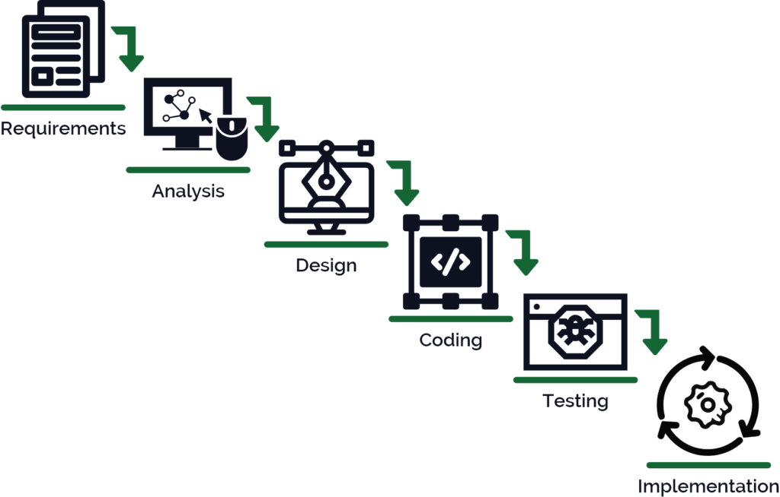

Figure 5. Waterfall Model

Gathering and analyzing requirements
The requirements for the Digital Health Records Management System were gathered through interviews with a nurse at Filamer Christian University. The interview process provided critical insights into the current workflow and challenges faced by healthcare personnel in managing student health records.
In the current process, when a patient visits the clinic, the first step is to ask if they have any past medical records. If they do, the records are retrieved; if not, a new form is filled out. Medical history is manually documented through interviews and written findings. The nurse records essential patient information, referring to the medical chart for details. However, a major challenge in the system is the manual recording and retrieval of medical history. Past records are stored physically in metal locker drawers, which makes accessing and managing data cumbersome. Additionally, students sometimes forget they have previous records, leading to duplicate entries in the system when new forms are filled out. The records are updated each time a patient visits, and master lists from each department are used to ensure accuracy and eliminate outdated information. The records of students who graduate or drop out are also pulled out regularly to decongest the storage.
Staff members play different roles in the data gathering process. The working student typically conducts patient interviews and gathers initial information. If needed, the nurse and doctor step in to complete the process and provide further input. This decentralized approach to data collection creates potential gaps in efficiency and consistency.
Key features desired in a digital health records system include the ability to manage and organize patient records seamlessly, with a focus on efficient data retrieval and elimination of duplicate records. Additionally, there is a need for a clinic reservation system, particularly during events such as sports and performances, when a large number of records (e.g., for athletes and dancers) must be prepared quickly and efficiently.
System Design
The system design phase involves defining the system's elements, such as modules, architecture, components, and their interactions, based on the specified requirements. This phase outlines how the system will function and meet the needs of the clinic by breaking down the system into manageable and coherent parts. It encompasses both broad design and detailed design.
Broad Design
The broad design refers to the creation of the system’s overall framework, which is driven by the needs of the Filamer Christian University Clinic. It serves as the foundation of the system, ensuring that it addresses core functionalities like managing medical records, scheduling appointments, and organizing patient information. This phase provides the general layout and conceptual approach for how the system will operate.
Detailed Design
The detailed design phase focuses on the more granular elements of the system, such as the database design, interface layout, and user specifications. It specifies how the system will function in practice and how it will handle various tasks, such as storing patient health records, ensuring data security, and managing user interactions. It also outlines the system specifications, describing the inner workings of the system, including database tables, relationships, and user roles.
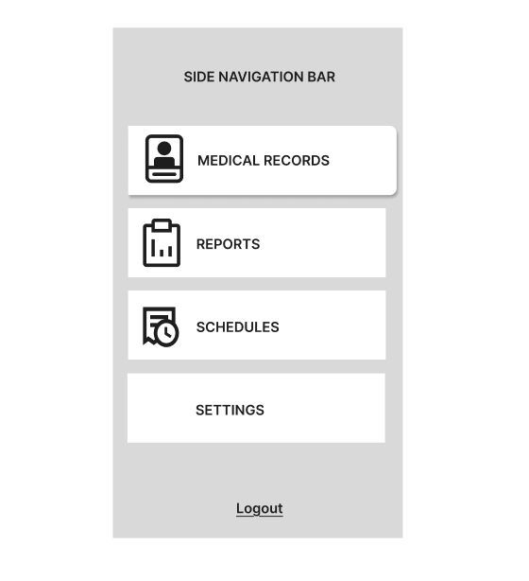
Figure 6 Prototype of DHRM Interface
The Digital Health Records Management System will allow healthcare personnel at Filamer Christian University to manage and interact with patient records. The system will
have an intuitive user interface where staff can input necessary data regarding patients’ health histories, appointments, and medical conditions.
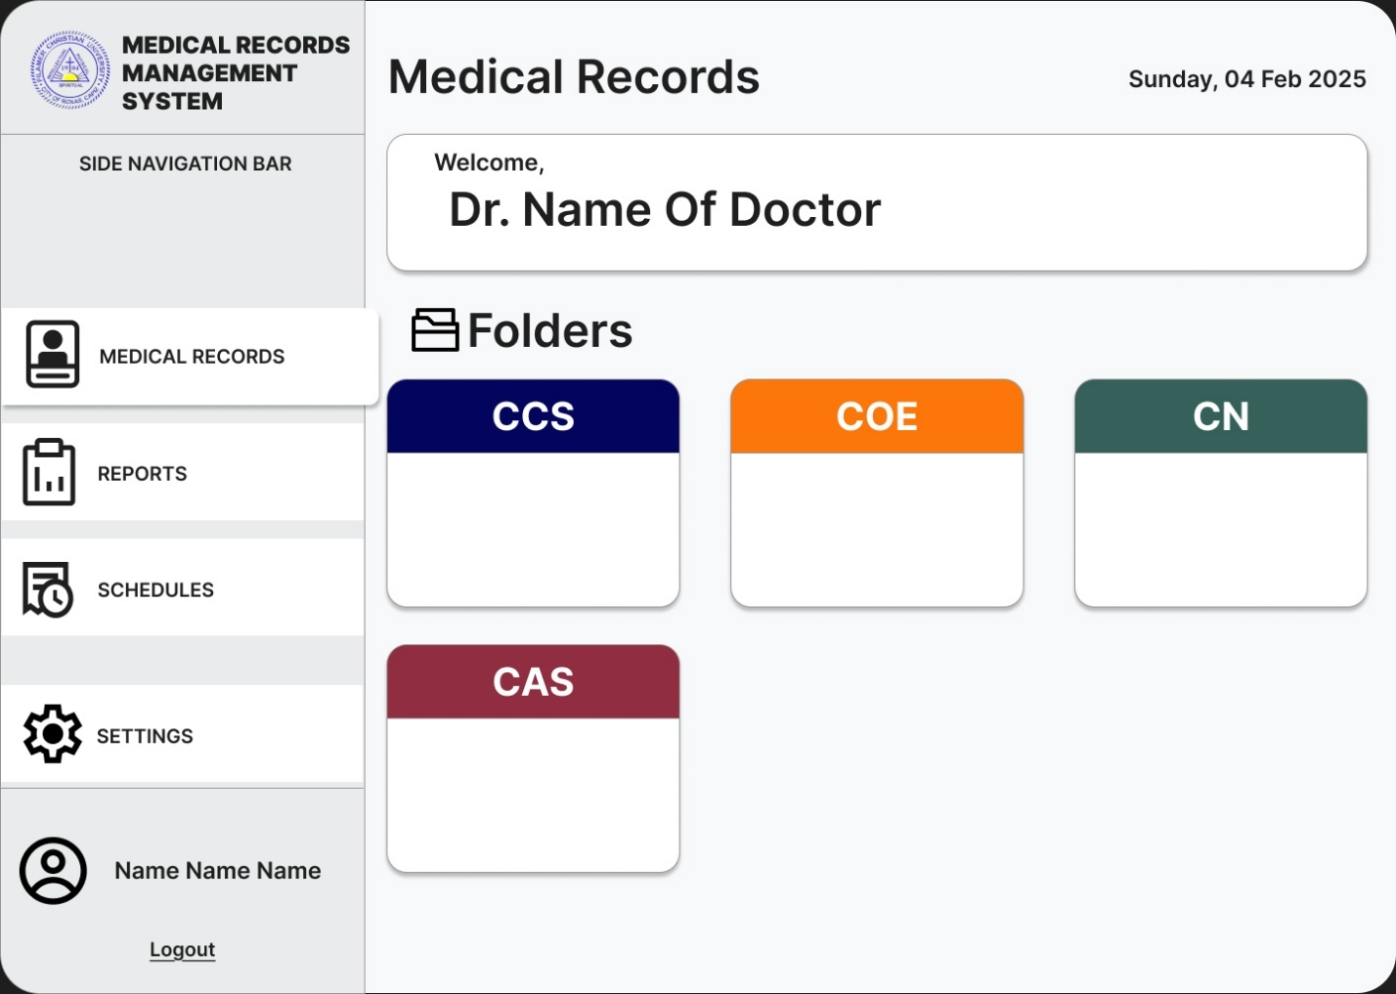
Figure 7 Medical Records
As shown in Figures 7, the interface will display Medical Records. This information will be crucial for easy retrieval and monitoring of health records. The system will also allow staff to update patient data, ensuring accurate and organized records. For first-time visits, the system will automatically generate a new record; for returning patients, the system will retrieve and update existing information.

The system will integrate multiple modules, each focused on different aspects of patient management. These modules include:
Records Management Module: For storing, updating, and retrieving patient records.
Schedule Module: For managing appointments and health check-ups.
Report Module: For generating reports related to patient health, clinic activity, and scheduling.
Each module will work together to provide a seamless experience for healthcare staff and ensure that patient data is secure, accurate, and easily accessible.

Implementation
The implementation of the Digital Health Records Management System involved the use of various programming languages, frameworks, and tools. The backend of the system was developed using PHP, utilizing the Laravel framework for its robustness, scalability, and ease of maintenance. For the front-end, Tailwind CSS was used to create a responsive, user-friendly interface. The database was managed through MySQL, which ensured secure storage and retrieval of health records.
The implementation process included multiple stages of testing to ensure the system’s functionality and reliability. Unit testing was carried out to verify the performance of individual components, such as data entry forms and user authentication mechanisms. Following this, integration testing was performed to ensure that different modules of the system, including the front-end interface and back-end database, operated seamlessly together. Finally, User Acceptance Testing (UAT) was conducted, allowing actual users, particularly nurses, to test the system in real-world scenarios to confirm its effectiveness in meeting their needs.
Maintenance
To ensure the continuous functionality and performance of the system, several maintenance strategies were planned. Regular bug fixes will be carried out to address any issues that arise during the use of the system. In addition, the system will undergo periodic updates to enhance its functionality, incorporate new features, and ensure compatibility with technological advancements. To safeguard against data loss, regular backups of the health records will be scheduled, ensuring that data remains secure even in the event of system failure. Furthermore, the system’s performance will be consistently monitored to identify and resolve potential inefficiencies or bottlenecks.

BIBLIOGRAPHY

Assessment of Electronic Health Record Use Between US and Non-US Health Systems, A. Jay Holmgren, MHI^{1,2}; N. Lance Downing, MD^{3,4}; David W. Bates, MD, MSc^{5,6}; (2020) https://jamanetwork.com/journals/jamainternalmedicine/fullarticle/2774129

Measurement of clinical documentation burden among physicians and nurses using electronic health records: a scoping review, Amanda J Moy, Jessica M Schwartz, RuiJun Chen, Shirin Sadri, Eugene Lucas, Kenrick D Cato, Sarah Collins Rossetti (2021)
https://academic.oup.com/jamia/article/28/5/998/6090156

Analysis of Digital Information Management Strategies by the Faculties of Higher Education Institutions, Ashoka R., Pavan N.S, Priya R. (2022)
https://digitalcommons.unl.edu/cgi/viewcontent.cgi?article=14560&context=libphilprac

A SMART AND USER-FRIENDLY INTERFACE FOR STORING AND RETRIEVING PERSONAL MEDICAL RECORDS, G. Swathi1 , H. Rakshana 2 , Dr. T.M. Usha mary

Document Management System – A Way to Digital Transformation, Sandra Jordana , Simona Sternad Zabukovšekb , Irena Šišovska Klančnikc (2022)
https://intapi.sciendo.com/pdf/10.2478/ngoe-2022-0010

AUDIT OF A WEB-BASED ELECTRONIC DOCUMENTS AND RECORD MANAGEMENT SYSTEM (WEDRMS): OVERSIGHT EFFORTS TO IMPROVE ADMINISTRATION IN HIGHER EDUCATIONAL INSTITUTIONS, Richatul Jannah1 , Fitrarena Widhi Rizkyana2, Risanda Alirastra Budiantoro3 (2022)

Electronic document management system for local area network-based organizations, Marlon V. Gamido, Heidilyn V. Gamido, Daryl James P. Macaspac (2023)

Development of Document Management System (DMSys): A Step Forward to a Paperless Office, Rafizah Mohd Hanifa, Nurul Khairisha, Afza Khairuddin, Nurul Qismina Rosdi, Lydia Betty Anak Thomas, Shamsul Mohamad (2023)
https://myjms.mohe.gov.my/index.php/ijbtm/article/view/24861

MediCord: A Web-Based Health Record Management System, Cris Norman Olipas, Jericho P Viloria, Stephany M Mateo, Sophia Angeline P Sta Maria, Ellaine A Bisnar, Mary Lyka M. Vallecera (2022)
https://www.researchgate.net/publication/364324883_MediCord_A_Web-Based_Health_Record_Management_System

Public Health Record Management System: An Up-Close Monitoring System, Jayson A. Batoon 1 , Alfredo B. Benitez 2 , Kurth Z. Cajucom3 , Mark Joseph M. Dalusung4 , Selwyn Jay D. Faustino 5 , Irish Nicole D. Galvez 6 , Lowell John L. Mercado 7 (2022)

https://www.researchgate.net/publication/286799181_An_evidence-based_health_information_system_theory
https://www.paramcs.com/Document-Management-Software.html

